Higher Certificate In Web Development and Mobile application(HAW1)

XHAW5112-POE

27/08/2025

Group 1

(Binary Brains©)

ST10497775

ST10469669

ST10496115

***Table of Content***

1.Milestone2-----------------------------------------------------------------pg1-5

Phase-1-------------------------------------------------------------------pg1

Phase-2-------------------------------------------------------------------pg2

Phase-3----------------------------------------------------------------pg3-5

Library or components used ---------------------------------------------pg.8

Reference list ------------------------------------------------------------pg.9

AI disclosure in this report --------------------------------------------pg.10

***1.Milestone 2***

***Phase-1***

***Objectives:***

Select the best logo.

Based on our previous assignment Milestone 1 All Members of a Team were required to design a logo that’s simple, professional and visually appealing to eye ,that matches the scenario empowering the nation using any online tools such canvas, BarndCrowd,.etc.

***Logo-1***(ST10497775) (BADIANYAMA MUTOMBO BLESS)

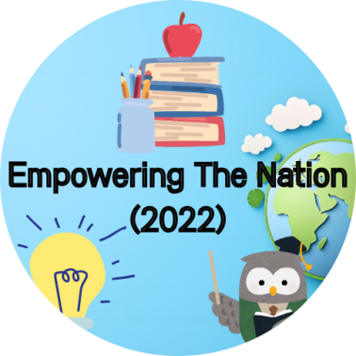

***Logo-2***(ST10469669) (KAY)

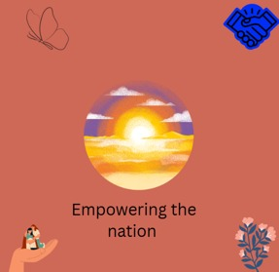

***Logo-3***(ST10496115) (SALLY)

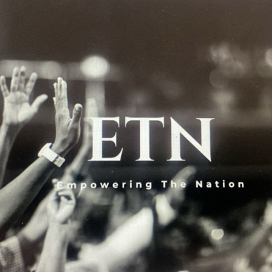

***Conclusion***

*After Careful evaluation and thoughtful considerations, we came to an agreement on the best approach to move forward we will be selecting logo-1 for future project.*

***Phase-2***

(assigned to ST10469669)

***Objectives:***

Provide detailed designs for the web page which includes the user interface, colours, functionality of buttons and links, SEO/tags Designs for each page are required

***Website***

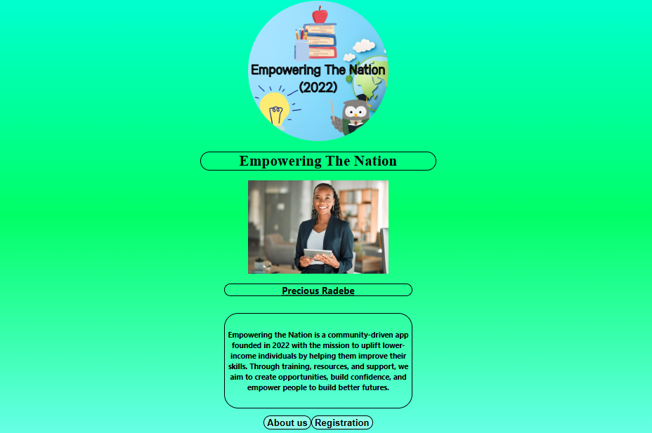

***Welcome Page***

*This page introduces the Empowering The Nation (2022) app by showing its logo, title, and a profile (Precious Radebe) to give a personal touch, along with a mission statement that explains how the app helps individuals improve skills, build confidence, and create opportunities. At the bottom, there are two buttons: About Us for learning more about the organization and Registration for users to sign up. The green gradient background was chosen because green symbolizes growth, renewal, and opportunity, reflecting the app’s goal of uplifting and empowering people in a welcoming way.(ETN,2022;Binary brains,2025)*

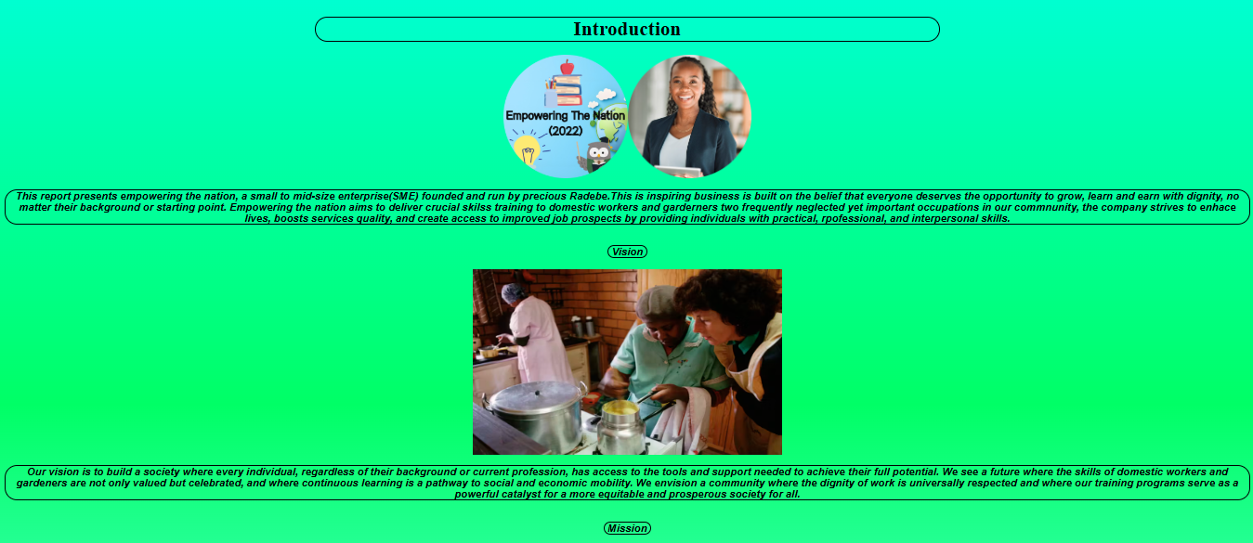

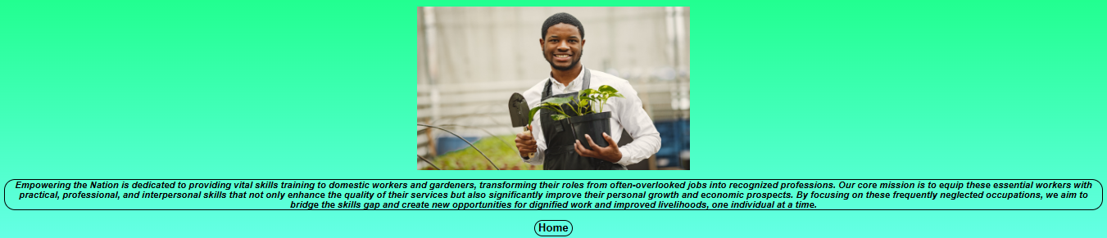

***About Us Page***

The About Us page for Empowering the Nation (2022) introduces the organization and its mission.

It explains that Empowering the Nation, founded by Precious Radebe, is a community-driven initiative dedicated to helping people from all backgrounds gain valuable skills, confidence, and opportunities for a better future. The page highlights the organization’s commitment to providing training for domestic workers and gardeners, enabling them to transform their roles into recognized and respected professions.

A key focus is ensuring workers receive practical, professional, and employable skills, which not only improve their own livelihoods but also contribute to economic growth and stronger communities.

The green gradient background was chosen to symbolize growth, hope, and renewal, perfectly matching the vision of uplifting and empowering individuals. At the bottom, a Home button helps users navigate back easily.

This page communicates both the values and purpose of Empowering the Nation, while building trust and inspiring users to engage with the initiative.

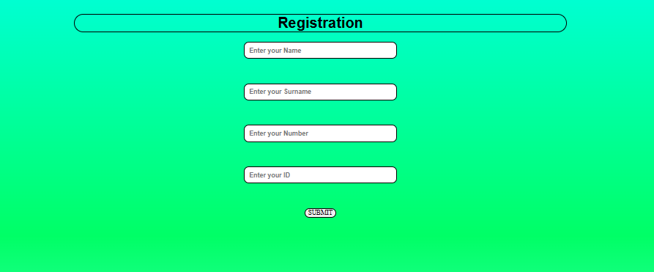

***Registration Page***

This is the registration page for the company Empowering the Nation (2022).

* Name – where the user types their first name.
* Surname – where the user enters their family or last name.
* Number – for providing a valid contact number, allowing the company to communicate with the registrant.
* ID – for entering an official identification number to verify identity and avoid duplicates.

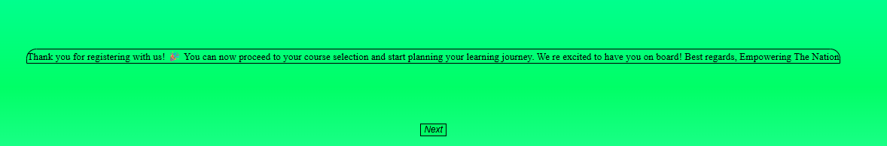

***Thank you, page,***

This is the Thank You page for Empowering the Nation (2022).

It confirms that the user’s registration was successful with a message of appreciation:

“Thank you for registering with us! You can now proceed to your course selection and start planning your learning journey. We’re excited to have you on board! Best regards, Empowering the Nation.”

The page reassures users, gives clear next steps, and includes a “Next” button to continue to course selection.

***Phase-3***

(assigned to ST10497775)

***Objectives:***

Provided detailed designs for the mobile app which includes the user interface,colours,functionality,buttons,links,design for each screen is required

***Mobile app***

***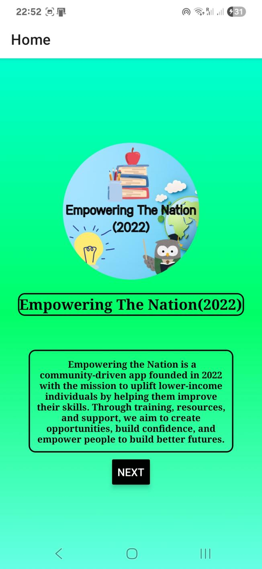****Based on the scenario, the key focus is to enable people to register for the course. Since course registration cannot be completed without obtaining their credentials, the agreed way forward is to design and create pages/frames specifically for credential acquisition. This step will ensure that all required information is collected properly before moving ahead with the registration course process.*

***Frame-1***

*landing page mock up for Empowering The Nation founded in 2022, a community-driven app created to uplift lower-income individuals. The app’s mission is to provide training, resources, and support to help people improve their skills, build confidence, and create better opportunities for their future. It features a clear title, a short description of its purpose, and a prominent Next button to encourage users to join, with development credited to binary brains. ( ETN,2022; Binary brains)*

*(Still in Development Further Changes will be implemented;)*

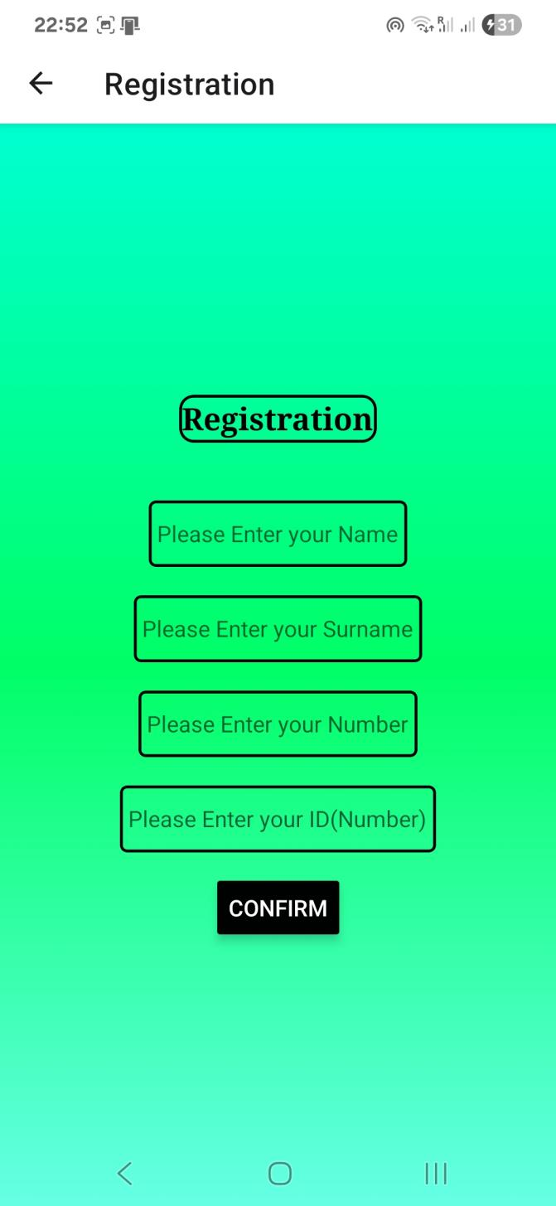***Frame-2***

*This screen is part of the registration process for the Empowering the Nation app. It is a credential acquisition page, where users are required to provide personal details such as their name, surname, phone number, and ID. Once the fields are completed, pressing the Confirm button will take the user further into the next Screen.*

*You would have reached this screen by first clicking the “Next” button on the landing page. That action transitions the user into the registration flow, starting with collecting the essential personal information needed for course*

*enrollment.( ETN,2022; Binary brains,2025)*

*(Still in Development Further Changes will be implemented;)*

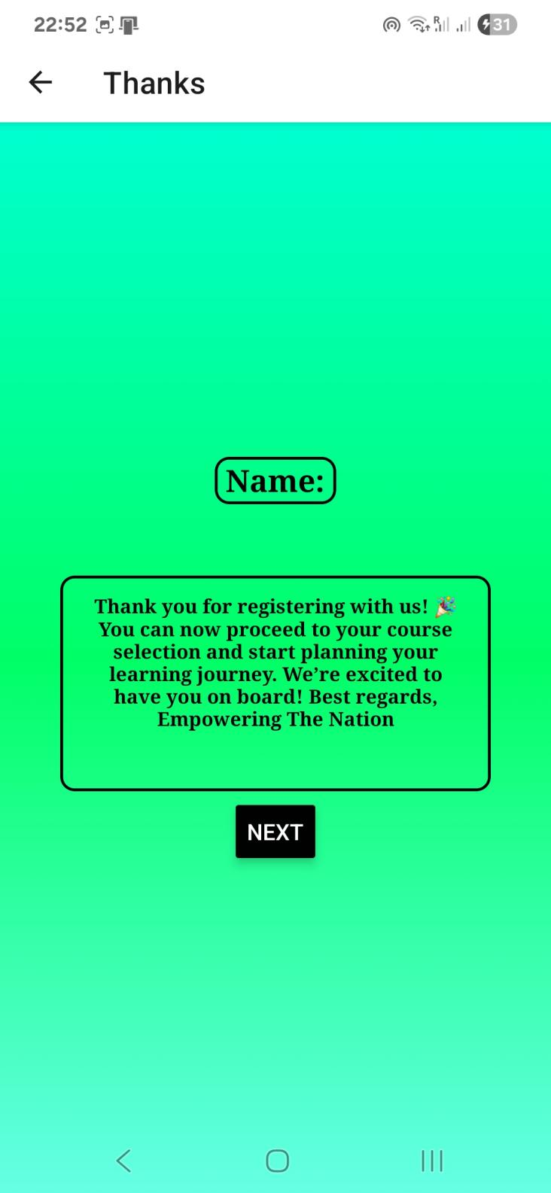***Frame-3***

*This screen in the Empowering The Nation app serves as a confirmation page. It displays the user’s their name, This screen follows the credential acquisition page, where users entered their personal information. After clicking the "Confirm" button on the previous screen, u and proceed further in the*

*registration process with course selection next up.( ETN,2025;Binary brains,2025)*

*(Still in Development Further Changes will be implemented;)*

*Table of libraries and components used*

| ***Library*** | ***Component*** | ***Explanation*** | ***Reference*** |
| --- | --- | --- | --- |
| *React Native* | *View* | *Basic container component for layout and design.* | *(React Native, 2025)* |
| *React Native* | *Scroll View* | *Enables scrolling content vertically or horizontally.* | *(React Native, 2025)* |
| *React Native* | *Text Input* | *Used to create input fields such as a search bar.* | *(React Native, 2025)* |
| *React Native* | *Touchable Opacity* | *Used to create interactive buttons, such as a home button.* | *(React Native, 2025)* |

*Reference list*

1. ***React Native Documentation*** *React Native components such as View, Text, Text Input, Touchable Opacity, and Scroll View are used for UI development and user interaction.  
   Source: React Native Official Docs (2025)  
   URL: https://reactnative.dev/docs/components-and-apis*
2. ***React Navigation Documentation*** *Used to manage screen transitions and navigation flows within the app (e.g., moving from Landing Page → Registration → Confirmation → Course Selection).  
   Source: React Navigation Official Docs (2025)  
   URL: https://reactnavigation.org/docs/getting-started*
3. ***Empowering The Nation App (2022)*** *A community-driven mobile application founded in 2022 to uplift lower-income individuals by providing training, resources, and support to help build skills, confidence, and better opportunities.  
   Development credited to Binary Brains.*
4. ***Colour Psychology - Green*** *Green symbolizes growth, renewal, and opportunity, aligning with the app’s mission to empower and uplift users.  
   Source: Colour Psychology (2025)  
   URL: https://www.colorpsychology.org/green/*
5. ***Design Principles*** *Use of personal profiles (e.g., Precious Radebe) and mission statements for building trust and relatability in community-driven apps.  
   Source: UX Design Best Practices (2024)*

***AI disclosure on this report***

* *10 September 2025*
* *Open AI 2025 version 4*
* *In this report we asked Ai to generate the library table for us and the reference list. We also asked it to polish our grammar in the lines.*
* 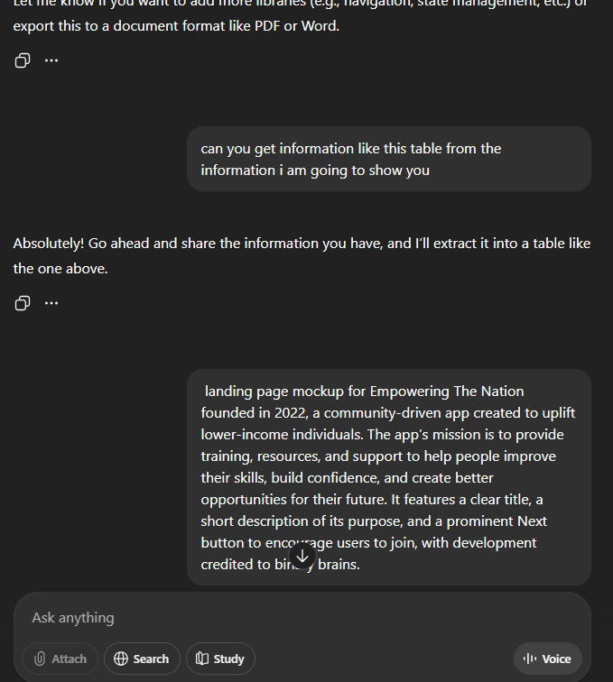
* *A screenshot of a computer

  AI-generated content may be incorrect.*